Reactor Accident Recovery & Lessons Learned

Lake H. Barrett

Introduction

Thirty four years ago, the United States experienced a major power reactor core melt accident at the Three Mile Island facility near Harrisburg Pennsylvania. This was a traumatic event for the US nuclear energy industry. However the reactor was cleaned up, lessons were learned, and in time the nuclear industry became safer and more productive as a result. Although the Fukushima Daiichi accident is more severe than Three Mile Island, there are many similarities and Japan has the capability to cleanup, recover, and move forward to make its nuclear industry safer and stronger. However, Japan will have to decide if it is willing to make the necessary changes for safe, secure, reliable and affordable nuclear energy to support its modern society.

Reactor Accidents

Three Mile Island

The Three Mile Island site has two Babcock & Wilcox pressurized water reactors: Unit 1 at 792Mwe and Unit 2 at 880 MWe (Figure 1)

. 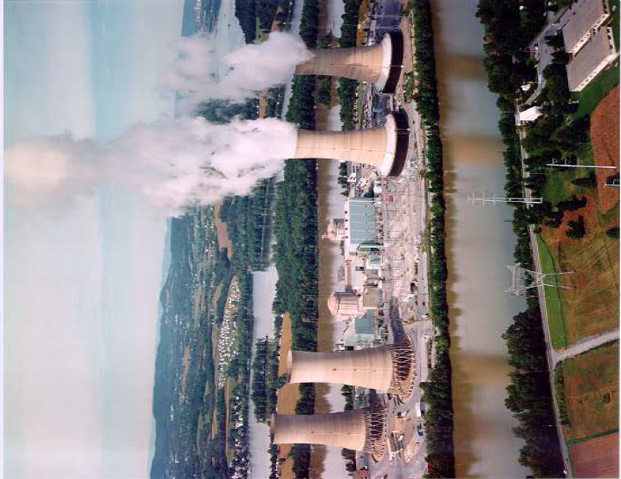
Figure 1, Three Mile Island Units 1 & 2

At 04:00 on 28 March 1979, Unit 1 was shut down for refueling and Unit 2 was operating at full power. There was a malfunction in a Unit 2 feed water pump that led to a turbine trip and automatic reactor shutdown. However, there was a stuck open reactor pressurizer relief valve that was unnoticed by the operators. The operators mistakenly thought there was too much water in the reactor, whereas in actuality there was a loss of coolant that allowed the core to become uncovered, overheat, and melt. At approximated 07:30 the core melted releasing hydrogen gas and highly radioactive fission products from the primary coolant system and into the containment building. At 13:00 the hydrogen gas ignited, however the pressure wave was contained by the approximate 1 meter thick reinforced concrete containment building. There were very small releases of airborne radioactive materials, however due to the uncertainties, a precautionary evacuation was recommended and approximately 140,000 people left their homes for about a week. Continuous cooling of the severely damaged core was established around 10:00 and the situation was technically stabilized despite considerable public concern. There was virtually no radiological impact on the public

Fukushima Daiichi

Fukushima Daiichi (figure 2) has six General Electric Boiling Water reactors of which three were operating and three were shut down for maintenance when the earthquake and tsunami struck on 11 March 2011.

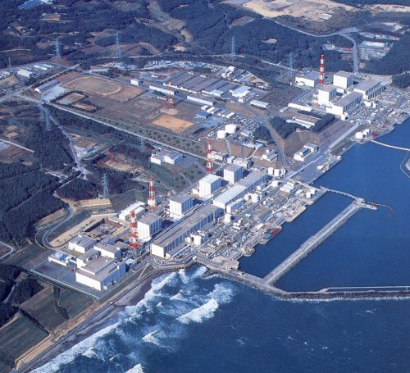

Figure 2, Fukushima Daiichi Units 1-6

The unanticipated large tsunami flooded the electrical systems and the operators were not able to add water to the cores such that the three operating reactor cores melted. Hydrogen gas and highly radioactive fission products were released into the primary containments, however these containments became over pressured, due to lack of cooling, and substantial amounts of gases were released into the secondary containment reactor buildings. The hydrogen gases exploded in three reactor buildings causing additional major damage at the site. Extensive on site and off site radioactive contamination occurred. Continuous water injection to cool the destroyed cores of Units 1, 2, & 3 was accomplished within a few days.

Public health and safety was accomplished by evacuations. Despite a considerable release of radioactivity, there is not expected to be any measurable impact on public health and safety. However there is significant offsite contamination that has major land use impacts.

Accident Recovery & Cleanup

Three Mile Island

When the accident occurred over one thousand experts from the US nuclear industry assembled at the site to help recover from the accident. Core cooling systems were established, special air filtration systems were installed, special radioactive water storage and processing systems placed in service (figure 3),

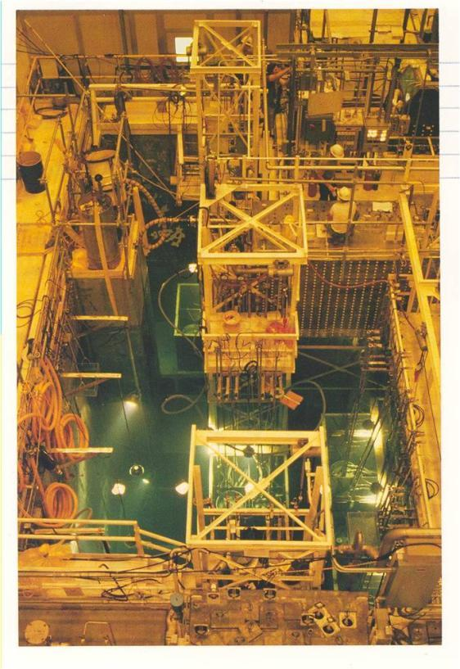

Figure 3, Submerged Demineralizer Water processing System

and radioactive solid waste management systems (figure 4) put in place.

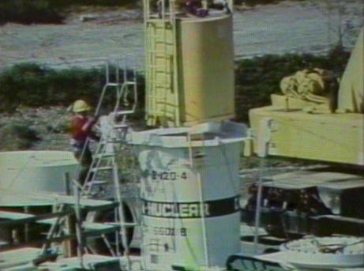

Figure 4, Solid Waste Handling System

Decontamination of building internals started (figure 5) and recovery plans were made to move forward to cleanup and remove the melted core. A new billion dollar financing arrangement had to be created to pay for cleanup and defueling.

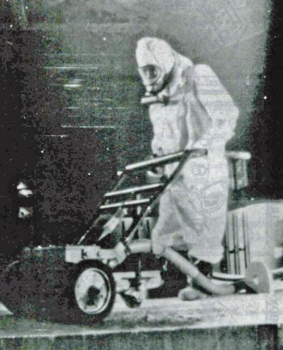

Figure 5, Surface Decontamination

After six years of cleanup progress, underwater defueling operations began with drilling and cutting of the solidified core debris to load it into special canisters (figure 6).

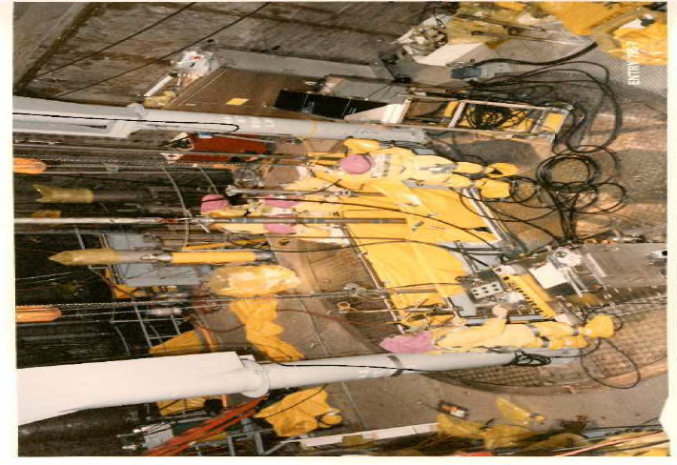

Figure 6, Defueling Operations

The spent fuel was transported off site for research and development lessons learned (figures 7 & 8). Highly radioactive solid wastes were disposed of in special burial packages (figure 9).

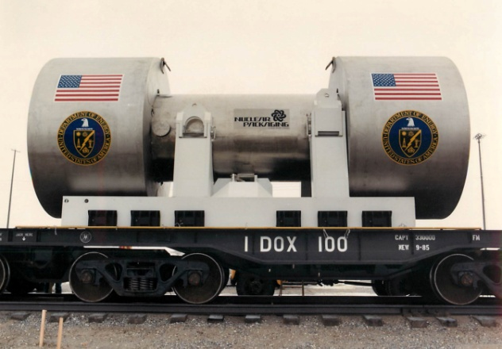

Figure 7, Spent Fuel Shipping Cask

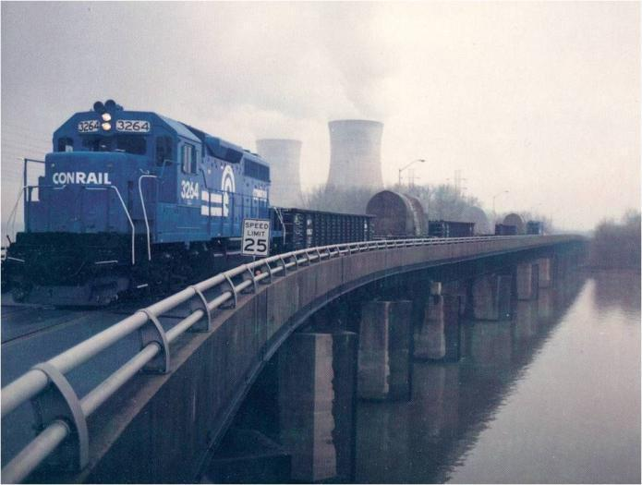

Figure 8, Last Spent Fuel Shipment Leaving TMI in 1990

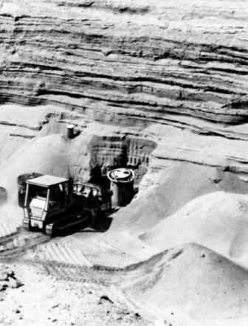

Figure 9, Disposal of High Integrity Solid Waste Container of Spent Water Cleanup Media

The cleanup was completed in 1993 at a present worth cost of about $2.3 billion. The defueled Unit 2 reactor is currently in a “safe store” mode and will be dismantled when its sister Unit 1 finishes commercial operation in approximately 2033.

Fukushima Daiichi

TEPCO has assembled a large team to stabilize and begin cleaning up the site. The task is much more complex than Three Mile Island because of the more extensive damage to site infrastructure, more severe core melting of three cores (where it is likely that there has been melted core leakage from some reactor vessels), much higher and more widespread contamination and radiation, and much more radioactive waste water and radioactive solid wastes to manage and dispose of. TEPCO has created an overall plan and work is progressing.

Lessons Learned

After the Three Mile Island accident there were many lessons learned and action plans were adopted by the nuclear industry and Nuclear Regulatory Commission to bring about the necessary changes in reactor management and operations. The main focus was the implementation of a disciplined operational safety culture throughout all organizations. The Institute of Nuclear Power Operations was created and a safety conscious culture created in all nuclear organizations. Operator training was greatly enhanced. The Nuclear Regulatory Commission increased its focus on issues that had the most safety significance and transitioned toward risk informed regulation.

The improvements not only led to improved safety performance, but also to improved electricity productivity. Nuclear reactor capacity factors improved from approximately 65% in 1979 to over 90% today. Many consider the post Three Mile Island cultural improvements to have made nuclear energy stronger and more economical than before.

Reactor Restart

After the Three Mile Island Unit 2 accident, the owner, General Public Utilities (GPU), decided that they would invest to make the necessary changes to restart the undamaged Unit 1 reactor. After extensive Unit 1 lessons learned implementation was completed, GPU demonstrated their readiness to safely restart Unit 1 to the Nuclear Regulatory Commission. Upon completion of comprehensive open and transparent public hearings, permission was granted to restart Unit 1 in September 1985. Today, Three Mile Island Unit 1 is one of the best performing power reactors in the United States.

Future

The Three Mile Island accident was a terrible blow to the US nuclear industry when it happened. However, the nation pulled together to recover and clean up the site, learned its lessons, and created a safer and more productive nuclear industry than before. The most painful experiences can also be the most teachable. The outcome depends upon the actions taken by society as a whole as it has to decide what are the options and alternatives. The United States chose to correct, learn, change, and move forward so that nuclear energy is an important part of our electricity supply system today.

Japan now faces a similar and in many ways a more challenging situation. Japan needs safe, secure, reliable, and affordable electricity to sustain its advanced economy and society. Change is difficult and realistic energy alternatives are not easily achieved. If it chooses, Japan has the technological and human resources to clean up Fukushima, make the necessary nuclear improvements, and move forward as was done after Three Mile Island in the United States. If it will or will not, is solely dependent upon the Japanese people.

Lake H Barrett is a nuclear engineer and was the Director of Nuclear Regulatory Commission’s Three Mile Island Cleanup Site Office from 1980 to 1984.

